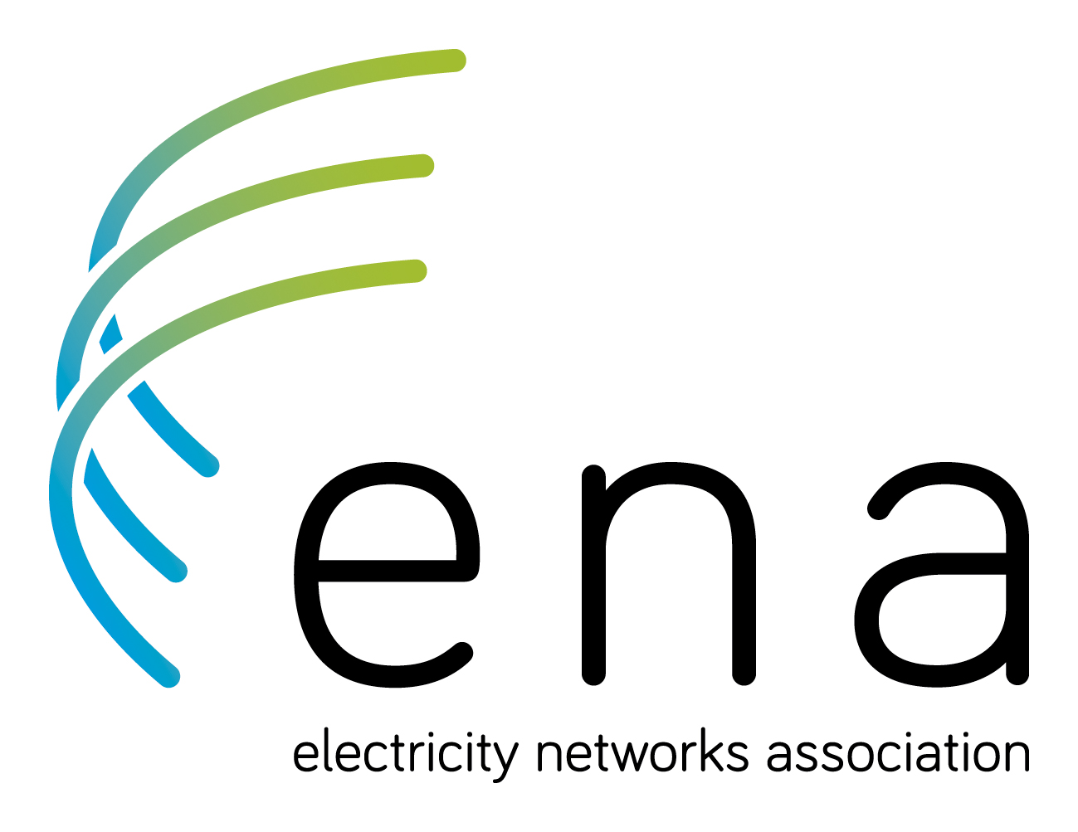



SUBMISSION FORM

## How to have your say

We are seeking submissions from the public and industry on our first report into the state of the electricity sector. The report contains a series of questions, which are listed in this form in the order in which they appear. You are free to answer some or all of them.

Where possible, please include evidence (such as facts, figures or relevant examples) to support your views. Please be sure to focus on the question asked and keep each answer short. There are also boxes for you to summarise your key points on Parts three, four and five of the report – we will use these when publishing a summary of responses. There are also boxes to briefly set out potential solutions to issues and concerns raised in the report, and one box at the end for you to include additional information not covered by the other questions.

We would prefer if you completed this form electronically. (The answer boxes will expand as you write.) You can print the form and write your responses. (In that case, expand the boxes before printing. If you still run out of room, continue your responses on an attached piece of paper, but be sure to label it so we know which question it relates to.)

We may contact you if we need to clarify any aspect of your submission.

Email your submission to energymarkets@mbie.govt.nz or post it to:

Electricity Price Review  
Secretariat, Ministry of Business, Innovation and Employment  
15 Stout Street  
PO Box 1473  
Wellington 6140

**Contact details**

| Name | Graeme Peters |
| --- | --- |
| Organisation | Electricity Networks Association |
| Email address or physical address | Level 5  Legal House  101 Lambton Quay  Wellington 6011 |

## Use of information

We will use your feedback to help us prepare a report to the Government. This second report will recommend improvements to the structure and conduct of the sector, including to the regulatory framework.

We will publish all submissions in PDF form on the website of the Ministry of Business, Innovation and Employment (MBIE), except any material you identify as confidential or that we consider may be defamatory. By making a submission, we consider you have agreed to publication of your submission unless you clearly specify otherwise.

## Release of information

Please indicate on the front of your submission whether it contains confidential information and mark the text accordingly. If your submission includes confidential information, please send us a separate public version of the submission.

Please be aware that all information in submissions is subject to the Official Information Act 1982.  
If we receive an official information request to release confidential parts of a submission, we will contact the submitter when responding to the request.

## Private information

The Privacy Act 1993 establishes certain principles regarding the collection, use and disclosure of information about individuals by various agencies, including MBIE. Any personal information in your submission will be used solely to help develop policy advice for this review. Please clearly indicate in your submission whether you want your name to be excluded from any summary of submissions we may publish.

## Permission to reproduce

The copyright owner authorises reproduction of this work, in whole or in part, as long as no charge is being made for the supply of copies, and the integrity and attribution of the work as a publication of MBIE is not interfered with in any way.

## Summary of questions

## Part three: Consumers and prices

**Consumer interests**

1. What are your views on the assessment of consumers’ priorities?

* ENA and its members have carried out research on consumer priorities[1], and these largely concur with the higher-level needs of consumers identified by the Panel as being centred around reliability, fairness and affordability.
* For example, the recent ENA-organised consumer reference panel of electricity consumer representatives ranked their “three most important values to consumers”. The most votes (in descending order) were received for:

1. Affordable
2. Low carbon
3. Reliable
4. Customer-focused
5. Resilient
6. Future-focused
7. Sustainable.

* Other research[2] we have undertaken has shown that consumers also greatly value *simplicity*, and that most consumers thought this was severely lacking in terms of both the structure of New Zealand’s electricity system and its billing practices.
* An overwhelming finding of consumer research we have undertaken (and that undertaken by CSIRO in Australia[3]) is that overall consumers do not generally want to spend much time or effort thinking about their electricity supply or its options. The exceptions to this are consumers who have embraced new technology such as solar photovoltaic panels (PV). These consumers were often much happier to be engaged. (ENA can provide summaries of findings from UMR reports on focus groups and a consumer panel.)

1. What are your views on whether consumers have an effective voice in the electricity sector?

* From our consumer research, most residential users prefer to be passive consumers, and not to have to think too much about their electricity supply. For instance, in terms of potential new technologies that may optimise their electricity usage and cost, most consumers researched have expressed a preference for set-and-forget options and/or automated demand management technology.
* Having said that, while most residential consumers struggle with what is perceived to be the overly complex nature of the electricity market, they also feel a sense of distrust that the industry as a whole is working to consumers’ best advantage.
* Although not specifically tested in our research, these consumers would almost certainly embrace the concept of some type of consumer advocacy representative, who would both understand the details and be trusted to stand up for their best interests.
* To ensure the consumer voice is captured, in addition to their own activity, ENA members have collectively been examining ways to engage more effectively with consumers.
  + Members established a Consumer Engagement Working Group. It has been meeting regularly during the past two years and provides a forum for members to share experiences and knowledge, as well as to work collaboratively. The working group has carried out focus groups and held a Consumer Engagement Panel trial in July 2018 (as mentioned above). All were professionally facilitated by UMR, an independent agency.
  + Members who have carried out consumer engagement say it is vital and informing, but also difficult, resource-intensive, and costly. Despite the hurdles, in future there will be more engagement.
* Elsewhere in the sector:
  + The Electricity Authority occasionally undertakes consumer research, but this is typically based around on-line surveys rather than personal, face-to-face engagement. Typically, its consultations are high-level and technical, with feedback mostly from industry participants and business consumer representatives, rather than small consumers.
  + The Commerce Commission similarly does not appear to have the resources to engage successfully with small consumers. It does, however, expect industry associations and individual EDBs to carry out increasing consumer engagement.
  + Consumer New Zealand is clearly an advocate for consumers, but it is not sufficiently resourced to satisfy the large and growing requirement for structured consultation with electricity consumers.
  + ENA is supportive of a mechanism that would give consumers more of a ‘voice’ in electricity, such as an Electricity Ambassador. We understand that the Electricity Retailers Association of New Zealand (ERANZ) also supports this solution.
* Finally, ENA would point out that ‘Figure 3, Mechanisms for Consumer Voice’ omits consumer trusts, which are elected by, and act in the interests of, consumers.

## Recommendation 3.1: ENA recommends that the Panel investigate non-regulatory options for supporting the consumer voice in New Zealand – possibly an electricity consumer ‘ambassadorial’ role or similar.

1. **What are your views on whether consumers trust the electricity sector to look after their interests?**

* With regard to the electricity sector as a whole, as evidenced by our own consumer research, there is mistrust that the sector is acting in the interests of consumers. This is most evident with respect to considerations of price and corporate earnings.
* Specifically, however, in relation to EDBs there is a greater level of trust that the local network operation is looking after the interests of consumers in terms of reliability, safety and resilience.
* Particularly in terms of recovery from storm events and other outages, there is often much trust and goodwill generated when consumers see maintenance crews working through the night in atrocious weather to restore lines.

1. **What are your views on the assessment of the make-up of recent price changes?**

* The Panel has chosen to examine price trends going back to 1990 although the electricity sector underwent considerable change in the 90s. This makes data comparisons difficult, unreliable, and inappropriate.
* In 1990, electricity companies were municipal electricity departments or power boards (integrated retailer and distributor model). These entities did not accurately allocate their costs to distribution and energy components as they were lumped together in one bill to the consumer.
* Moreover, the operating model at the time involved significant transfers of costs and risks to taxpayers. MEDs and power boards did not operate commercially and rate-payers, commercial and industrial customers subsidised residential power prices. Comparing prices now to those in 1990 would involve a significantly more sophisticated analysis taking those factors into account.
* We dispute the Panel’s view that distribution charges rose 548% between 1990 and 2018. Data from 1990 is not accurate and, as stated above, electricity suppliers were vastly different back then. ENA believes that the Panel would have been better to focus its data analysis from 2000.
* A PwC analysis of data from 2004 to 2017[4] is based on regulated information disclosure and is therefore a reliable snapshot of price trends.
* This 13-year analysis (pictured below) shows that distributor charges have increased an average of 1.4 percent per year in real terms, the lowest change of the five components of an electricity bill.

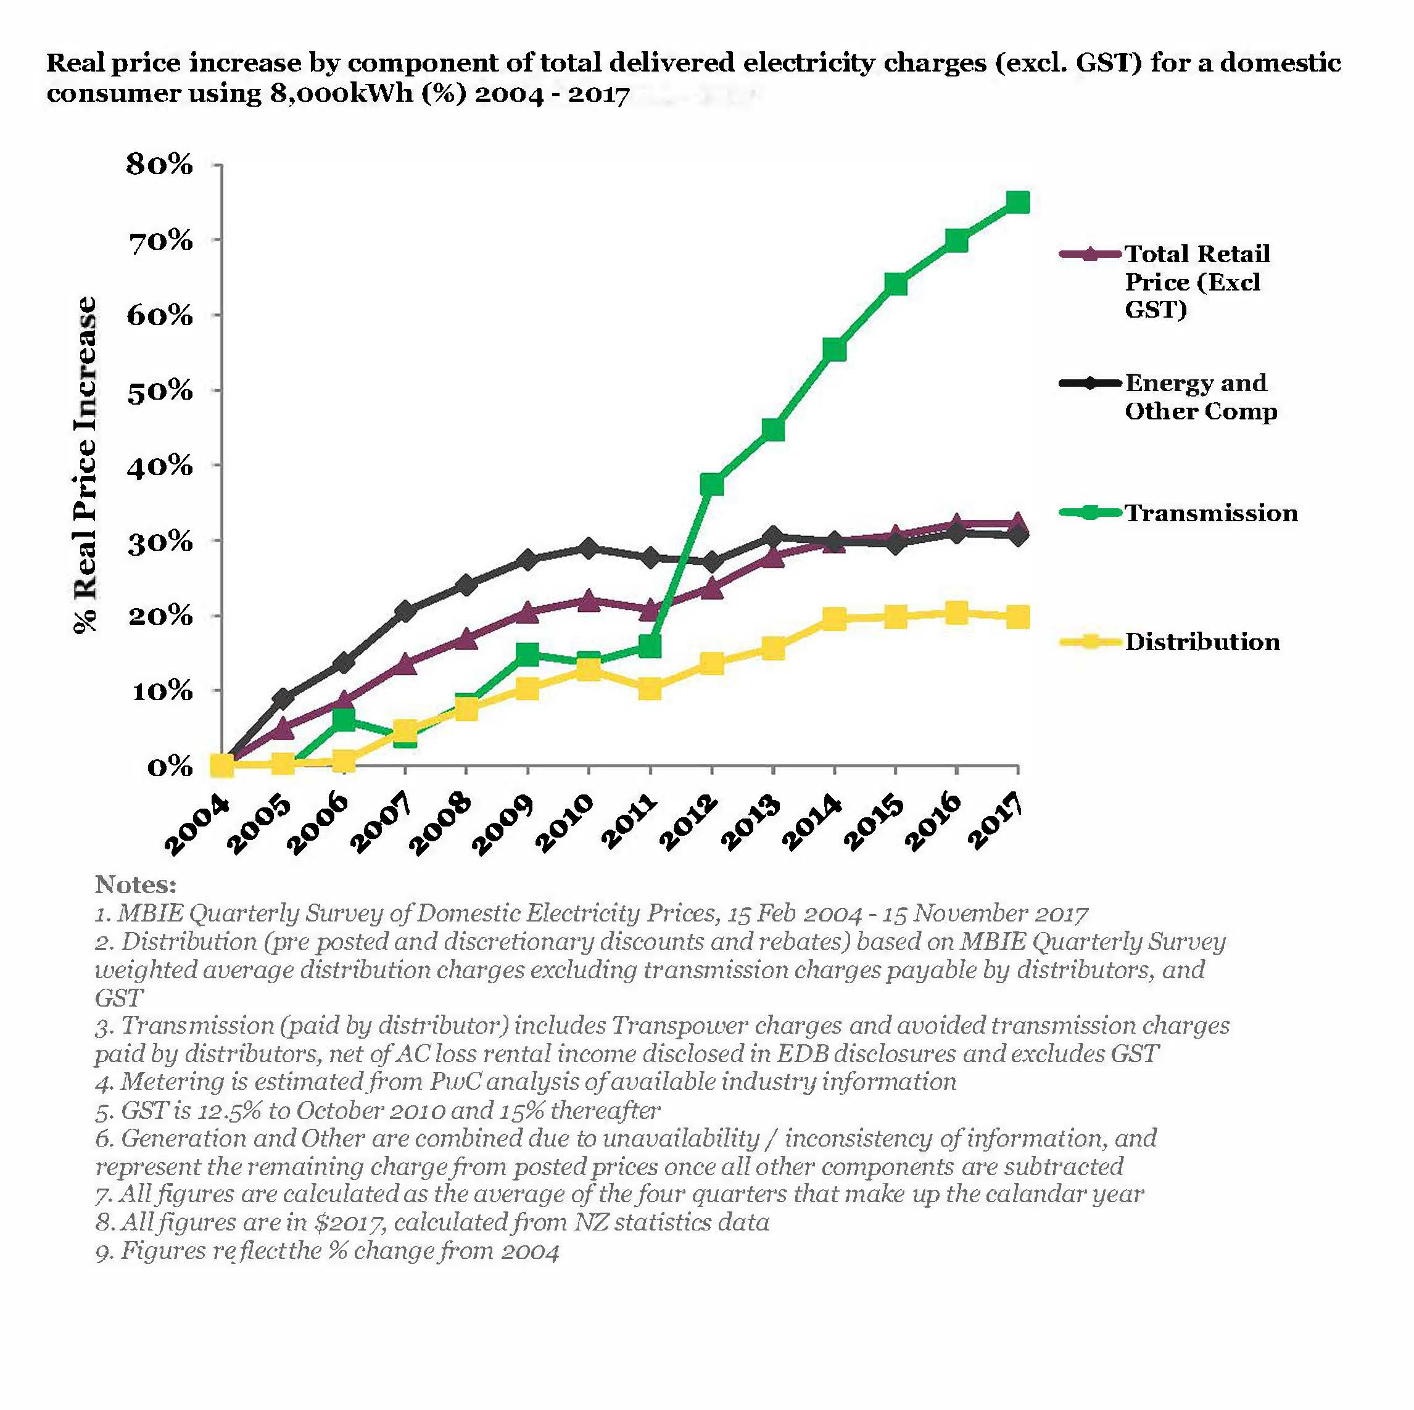

* Finally, it’s important to remember that electricity distribution charges are regulated under Part 4 of the Commerce Act.

1. **What are your views on the assessment of how electricity prices compare internationally?**

* New Zealand compares favourably with most other OECD countries in terms of electricity prices.
* New Zealand has the 12th lowest residential electricity prices in Figure 9 (a comparison of 34 OECD countries)[5]. This is a commendable result when considering New Zealand does not have the benefits of interconnection to other large electricity markets and the low density and difficult terrain we must deal with. We do accept, however, that there is a significant problem with affordability for a sizable group of consumers and that the electricity sector needs to play its part in addressing this, which requires effective competition in the contestable parts of the market and effective regulation where there is an absence of competition.
* New Zealand has the seventh lowest industrial electricity prices in Figure 10 (a comparison of 33 OECD countries).

(We note that Australia is missing from Figure 10 and that the OECD has 36 member countries.)

1. What are your views on the outlook for electricity prices?

* With the right regulatory and Government support, the outlook for NZ electricity prices is favourable, especially when considered against relative outlooks for other countries facing significant decarbonisation challenges. The general expectation is for New Zealand to meet growing electrification needs with renewable electricity sources, which should cost no more to develop than existing generation resources.
* Distribution prices appear to be set for a small decline at the 2020 reset (assuming interest rates remain low) and lift modestly over the regulatory period 2020 to 2025.
* Most networks are facing a wave of reinvestment requirements as assets built in the 1960s and seventies are due for replacement. Modern, equivalent commissioned assets tend to be more expensive than the heavily-depreciated old assets. This is because more exacting health and safety requirements have significantly increased the costs of installation, as have factors such traffic management requirements, consenting processes, and increased congestion on roads.
* An important factor impacting on delivered electricity prices is whether or not policy-makers can stay the path on network pricing reform. New technologies and improved housing stock provide some consumers with opportunities to reduce their contribution to paying for the costs of the network (distribution *and* transmission) infrastructure. To fund the shortfall, other customers, who are unable to access such technologies or make energy efficiency improvements, pay higher prices. This is because EDBs are required to recover an excessive proportion of their costs through variable network prices, due in large part to the Electricity (Low Fixed Charge Tariff Options for Domestic Consumers) Regulations 2004.
* Without network pricing reform and removal or substantial amendment to the low fixed charge regulations, affordability could get worse for some ‘have not’ customers. The New Zealand Institute of Economic Research has estimated that, within ten years, customers without solar panels could be paying an **extra 10% per year.[6]**
* To address future affordability concerns, the ENA is leading an industry effort to reform network prices. Members are aiming to implement more cost-reflective, service-based prices that harness the capability of smart meters to better reflect the structure of our costs to consumers. In this reform effort, the ENA recognises that changes in pricing structures can be very disruptive. Transition paths may be required so that consumers can adjust to them. We are committed to introducing pricing reform from 1 April 2020. Although it is likely to take a multi-year timeframe to reach a final position.
* Pricing reform needs to be supported by removal or substantial reform of the low fixed charge regulations. These poorly-conceived regulations provide real constraints on an efficient and effective price reform process. (See our answer to question 30).

## Affordability

1. **What are your views on the assessment of the size of the affordability problem?**

* ENA agrees with the Panel’s assessment that energy affordability is a significant issue. While it doesn’t have its own direct evidence (given that the primary responsibility with billing rests in most cases with the retailer), ENA is aware that some consumers struggle to pay their electricity bills.
* However, ENA agrees that not all low-income households are in energy hardship, as some might have low energy needs or alternative energy sources.
* ENA asks that the meaning of ‘vulnerable consumer’ or ‘energy hardship’ is clearly defined by government in consultation with the electricity sector. We understand that the Electricity Retailers Association of New Zealand (ERANZ) is carrying out international research into a suitable definition and look forward to discussing this with ERANZ.

1. **What are your views of the assessment of the causes of the affordability problem?**

* ENA agrees with the Panel’s assessment of the affordability problem.
* In particular, ENA agrees that some consumers are paying relatively too much for their electricity due to the emergence of a ‘two-tier’ market, late payment penalties, poor understanding of the various plans and charges, and limited choice for some consumers in financial hardship.
* The lack of awareness, knowledge, access to information or ability/willingness to engage with the competitive market on the part of some consumers contributes to the two-tier market, which penalises passive consumers who don’t actively search for better deals. (And generally retailers don’t actively go searching for them – lower income households are often not prime targets for retailers seeking to gain business by offering better deals).
* ENA believes that there needs to be a credible, respected and independent source of information and advice for consumers, especially those in energy hardship. We are aware that there are some entities which already offer this service in some parts of  
  New Zealand.
* While Power Switch and What’s My Number are useful on-line tools, there are few obvious options for New Zealanders wanting to, for example, talk to an adviser about the most efficient plans for a household, in conjunction with a discussion about technology or home-improvement options. (In Christchurch, the independent Community Energy Action organisation does provide components of this role, as does the Sustainability Trust in Wellington).
* To be effective in reaching the hard-to-reach demographic of consumers who are currently being penalised for their passivity, the energy ambassador function (see recommendation 3.1) must be well-promoted and must successfully find new ways to pro-actively engage with these demographic groups.
* The provision of such advice could potentially be packaged with an energy ambassador role as suggested above. (Or if, for instance, there were several ‘energy ambassador’ roles established regionally, it could be appropriate to consider that existing organisations such as Community Energy Action or the Sustainability Trust be invited to tender to provide this function in their regions, given their existing energy advisory knowledge and experience.)
* It is important to recognise that the causes of the affordability problem are complex and multi-dimensional. People in energy hardship are likely to face affordability challenges across a range of essential goods and services, including housing, transportation, and food. Housing quality is likely to have a particularly significant impact on low-income households. The consequence is that higher energy requirements are needed to heat poorly insulated, damp homes.
* As a result, ENA supports the Government’s initiatives to improve the quality of housing stock, which will have a far greater impact on consumers in energy hardship than any conceivable reduction in electricity prices, including significant health benefits from reduced respiratory illnesses.

## Recommendation 3.2: That the Panel encourages greater consumer access to credible, independent information about electricity prices, technologies, and energy conservation options to lower energy costs.

1. **What are your views on the assessment of the outlook for the affordability problem?**

* ENA agrees with the Panel’s assessment on the outlook of the affordability problem.
* In particular, ENA agrees that technology uptake will vary between consumers. Some will be able to afford alternative generation such as solar, energy storage devices, energy management systems, and electric cars which can be used for transport and energy storage.
* Others will not have the resources or knowledge to adopt these technologies in the short to medium term and will forgo the potential benefits they offer to affordability.
* ENA supports further social welfare measures such as enhancements to the winter energy payment. The payment does benefit many people on low incomes, but it is poorly targeted as it also benefits some consumers who might not be in energy hardship.
* ENA members have discussed the possibility of recommending that the government establish a retail option for those consumers who would otherwise struggle to find a competitively-priced electricity retailer – such as those in energy hardship or with sub-prime credit ratings. This would not involve the government establishing a stand-alone electricity retailer.
* This could involve aggregating the purchasing power of households at risk of experiencing energy hardship or exploring options for “credit wrapping” – i.e. providing a guarantee or security to ensure that this group of customers are able to pay their electricity bills.

## Recommendation 3.3: That the Winter Energy Payment be reviewed so it is targeted at those in energy hardship – which needs to be well-defined by a broad set of relevant factors (e.g. income, energy costs, quality of housing, household make-up, etc).

## Summary of feedback on Part three

1. **Please summarise your key points on Part three.**

**Consumers’ priorities**

* As well as valuing reliability, fairness and affordability, ENA research shows that consumers value *simplicity*.
* Consumers generally don’t want to spend much time thinking about their electricity supply options or trying to understand these complexities.

**Effective consumer voice**

* Most residential consumers, apart from occasionally changing retailers, prefer to be passive consumers. They are easily turned off by what they regard as an overly complex system but also have an underlying distrust that the entire electricity industry is working in their best interests.
* It is highly likely therefore that consumers would support an independent advocate working on their behalf.

**Consumers’ trust**

* There is widespread distrust amongst consumers on whether the sector as a whole is working in their best interests.
* Generally, consumers trust networks in terms of reliability, safety and resilience and generally much goodwill is generated by maintenance lines crews’ storm/outage recovery efforts in adverse weather conditions.

**Price changes**

* ENA disputes that the data from 1990 is reliable or accurate in terms of distribution pricing.
* Analysis by PwC of price changes between 2004 and 2017 shows distribution charges increasing an average of 1.4 percent per year in real terms, the lowest rate of increase of any of the five components of an electricity bill.

**International price comparisons**

* NZ compares reasonably favourably with other OECD countries, but there is a significant problem of affordability for some consumers.

**Outlook for prices**

* Future changes in distribution pricing will be impacted by:
  + Uptake of new technology and how it is used.
  + Effectiveness of load shifting away from peaks.
  + Uptake of electric vehicles.
  + Electrification and decarbonisation .
  + Consumer responses to price signals.
  + 2020 regulatory reset for non-exempt EDBs.

**Assessment of size of affordability problem**

* ENA accepts this is a significant issue.

**Assessment of causes of affordability problem**

* ENA agrees with the assessment of the causes of the affordability problem, and the existence of the two-tier retail market.
* ENA believes lack of knowledge or ability to engage with the competitive market penalises passive consumers who don’t seek better deals.

**Assessment of outlook for affordability problem**

* ENA agrees with Panel’s assessment.
* Technology uptake will be uneven and could exacerbate differences between consumers.
* ENA supports better targeting of the winter energy payment to help more effectively address affordability problem for those in real energy hardship.

## Solutions to issues and concerns raised in Part three

1. **Please briefly describe any potential solutions to the issues and concerns raised in Part three.**

**Energy ambassador**

* ENA agrees with the suggestion that an independent energy ambassador function (or similar) should be established to provide an effective voice on behalf of the consumer.
* From our own research and feedback, we are not convinced that the full Australian model (i.e. Energy Consumers Australia), is either necessary or appropriate in the New Zealand context.

**More accessible consumer information and advice**

* ENA supports initiatives to enhance the availability to consumers of high-quality, independent information and advice on tariffs and energy-saving options. This could be through both web-based and phone-based advice.

**Better targeting of energy affordability through welfare system**

* ENA believes that energy hardship or affordability is a broader social problem and cannot be related solely to access to energy. That said, we appreciate that electricity is not a luxury, but an ‘essential’ service for keeping people safe and warm, and businesses operating.
* It is neither desirable nor practical for electricity companies to be making judgments on who can and who cannot afford to pay their electricity bills. These judgments are complex and based on many factors, including confidential information such as incomes, work and tax status, age, health, and ability to access other subsidies. ENA believes that energy affordability should be part of this whole-of-government approach.
* We believe that the Government’s winter energy payment should be restructured to provide better targeted assistance to those in genuine energy-hardship, including low-income and/or large working households that currently aren’t eligible for the subsidy.
* ENA is also supportive of the work carried out by the Electricity Retailers Association of  
  New Zealand to examine the issues around energy affordability. ERANZ has put forward some practical suggestions for improving outcomes for some consumers in energy hardship which ENA believes merit further consideration.
* The government should consider the merits of establishing a retail option for those consumers that would otherwise struggle to find an electricity retailer.

## Part Four: Industry

**Generation**

1. **What are your views on the assessment of generation sector performance**No comments.
2. **What are your views of the assessment of barriers to competition in the generation sector?  
   No comments.**
3. **What are your views on whether current arrangements will ensure sufficient new generation to meet demand?**No comments.
4. **What are your views on the assessment of retail sector performance?**

**Retail Sector Competition**

* The ENA is aware of concerns about the limited increase in real competition in the retail sector. We appreciate that the EPR report[7] states “*By many measures, competition among retailers has strengthened in recent years*”, but the International Energy Agency’s most recent report on New Zealand said that the five big retailers accounted for 91% of generation and supplied 93% of customers in 2015.
* These proportions had changed over the preceding decade, but not by a large amount. In 2005, the big five retailers had 93% (down 2bp) of generation and 99% (down 6bp) of consumers.
* The IEA noted that this modest change “*could raise concerns of competitive price formation and behaviour, and hinder the efficient and innovative development of electricity markets*.” [8]
* The IEA said that, on the positive side, the concentration in the retail market as measured by the Herfindahl-Hirschman Index (HHI) had fallen from 4000 in 2011 to below 3000 in 2015. However, electricity markets with HHI indices above 2500 are considered “*highly concentrated*”.[9]
* The following graph demonstrates the trend of slow growth in market share of small and medium retailers:

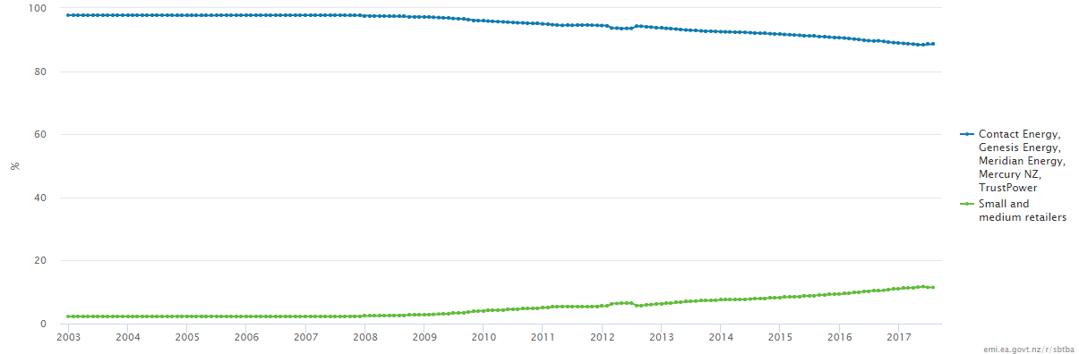

Source: EMI retail market share data, Electricity Authority website

* The IEA commented that while entry is possible for smaller firms, “*independent retailers have limited possibilities to expand their business. Ensuring a level playing field for new entrants and mitigating the ongoing dominance of the five big gentailers remains a key challenge for the government*”.[10]
* The IEA used data as at 2015[11]. The following table compares parent company[12] market share as at 31 July in 2015 and 2018[13]. As at 31 July 2018, the five largest incumbent parent company retailers had a market share of 88.6%, with the balance of 11.4% held by small and medium retailers, compared with 92.1% and 7.9% respectively in 2015. Only two of the five incumbent retailers have lower actual customer numbers at the end of July 2018 compared to three years ago.
* Small and medium retailers have gained an average of 1.2% market share each year (approximately 27,000 ICPs each year) or 16% of the average 170,000 ICPs that switch  
  each year.



Source: EMI retail market share data, Electricity Authority website

Note: Trustpower completed a takeover of King Country Energy’s retail customer base on 31 May 2018, increasing its market share by 0.75%.

* The Electricity Authority positively promotes that New Zealand now has 40 electricity retailers. Of this number, there are 35 small and medium sized retailers which together service 242,929 customers. Of these, 33 have a customer base that is less than a tenth the size of Trustpower - the smallest of the five incumbent retailers. Many stakeholders have queried whether there is a level playing field for these new entrants.
* Ecotricity characterised the attributes available to independent retailers - relative to incumbent gentailers when approaching a potential customer - in the following schematic”:[14]

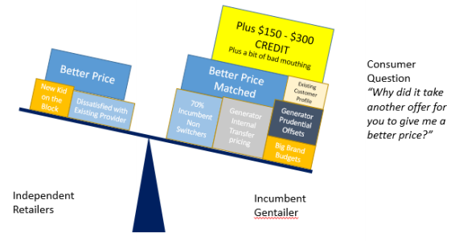

* ENA suggests there are a number of factors which supports the view that new entrants to retailing don’t face a level playing field. These barriers to entry contribute to slow growth in market share of new entrant retailers.
* The ENA notes that market concentration varies significantly by region, as is evident from the EMI HHI trends data prepared by the Electricity Authority.

## Two-tier market

* ENA agrees with Energy Minister Megan Wood’s comments, in a press release accompanying the issues paper, that “for residential customers it appears that a ‘two-tier’ market is developing”.
* As the Panel pointed out in its issues paper, some stakeholders have made similar comments about energy ‘haves’ and ‘have-nots’ based on those who shop around for the lowest prices.
* The ENA is strongly supportive of Electricity Authority research into potential savings of customer switching[15].
* The savings available across residential consumers if they had switched to the lowest priced generally available plan, was $242.18 a year in the South Island, and $195.57 in the North Island in 2017[16].
* In total, this is a saving for electricity consumers of $371.9 million that has been ‘left on the table’.

|  |  |  |  |  |  |  |  |  |
| --- | --- | --- | --- | --- | --- | --- | --- | --- |
|  |  |  |  |  | Per residential consumer | | | |
|  | 2016 | 2017 | Increase | | 2016 | 2017 | Increase | |
|  | $m | $m | $m | % | $ | $ | $ | % |
| North Island | 207.3 | 260.4 | 53.1 | 26% | 157.52 | 195.57 | 38.05 | 24% |
| South Island | 83.6 | 111.5 | 27.9 | 33% | 184.38 | 242.18 | 57.80 | 31% |
| Total | 290.9 | 371.9 | 81.0 | 28% |  |  |  |  |

Source: Electricity Authority website

* More concerning, the value ‘on the table’ increased 28% or $81 million in 2017, compared with 2016.
* In a highly competitive market, the savings on offer to consumers should be significantly reducing over time, not increasing.
* According to Energyclub[17], the increase in potential savings indicates an “increased industry profit pool” versus the previous year, which has seen significant “hidden” incumbent price increases to their non-contracted customer bases.
* This profit pool is ‘owned’ by the incumbent gentailers with nearly 90% of households under their supply.
* The major retailers might attribute this 28% savings increase on distribution companies increasing charges, but the underlying data doesn’t support this.
* All retailers have experienced the same network company increases and hence, in a competitive market, the savings available should be relatively similar, or less, and not an overall 28% increase.
* The following map shows residential average savings by network area. The number of electricity retailers in each network area does not appear to be correlated with the savings residential consumers could make in each network area.

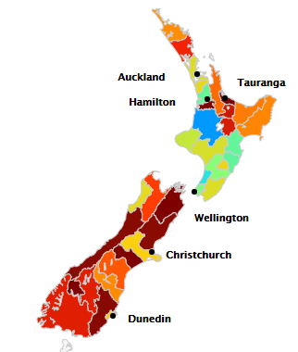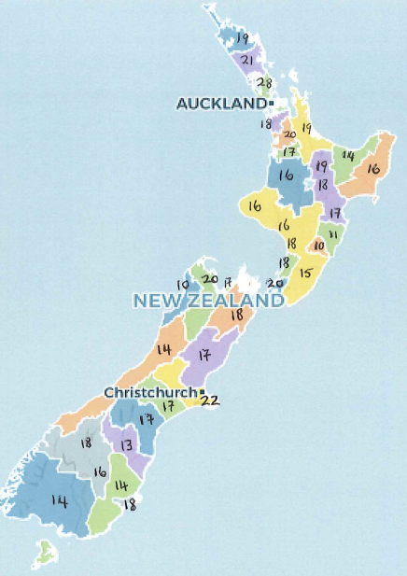

Annual savings for residential consumers by network area

Number of electricity retailers trading in each network area (July 2018)

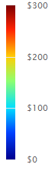

Source: EMI data, Electricity Authority website[18]

* Another way of assessing the significance of a ‘two-tier’ market is examining minimum and maximum tariffs. The Ministry for Business, Innovation and Employment used to compile a helpful survey on maximum and minimum residential tariffs. Unfortunately this survey ceased to provide this data after November 2013.
* The survey showed the difference between the average maximum and minimum tariff as well as the gap between the incumbent and minimum tariffs.[19] Incumbent tariffs exceeded the minimum tariffs by an increasing amount over time. There was a considerable difference between the maximum and minimum tariffs – with the maximum tariffs most likely to be offered by incumbents.
* A similar comparison on maximum and minimum tariffs was, in effect, analysed by Britain’s Competition & Markets Authority (CMA) investigation into the retail household energy market, completed in June 2016. This compared the standard variable tariff[20] (SVT) and other available tariffs, as well as investigating the types of households on different tariffs. The conclusion was:

Source: MBIE Quarterly Residential Price Survey 2013.

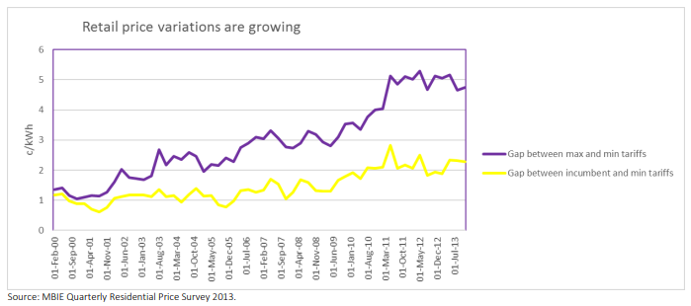

*“Disengaged households were generally on the evergreen SVT tariff, either because they had never made a positive choice, or because they had defaulted to the SVT at the expiry of a fixed term tariff.” [21]*

* The UK review, supported by an Australian review[22], identified a detriment to competition from retailers’ pricing. Retailers’ pricing discriminated against loyal ‘sticky’ customers who are effectively funding the better deals offered to ‘new’ and ‘leaving’ customers – the competitive tier. Sticky customers are also driving overall increased levels of profitability. The issue of ‘sticky customers’ is discussed in more detail below.
* Another contributor to some consumers paying high prices – and contributing to the ‘two-tier market - are the charges imposed on consumers buying electricity on a pre-pay basis. These pre-pay customers are often vulnerable consumers. [23].
* Ofgem is proposing to put a price cap on poor value default tariffs – legislation requiring Ofgem to design and implement this price cap has been passed by the UK Parliament.[24]
* In summary, ENA agrees with the Panel there is clear evidence of a two-tier market of consumers. This two-tier market requires more study and analysis than can be completed by the EPR Panel within its tight reporting timeframes and resources. The answers to addressing the two-tier market are not obvious, but there are solutions which have been used overseas that are worth considering in the New Zealand context.

**Possible Solutions**

Solutions identified in the British electricity price review and described in the Cave report included:

*- “the establishment by Ofgem of a programme to provide customers – directly or through their own suppliers – with information to prompt them to engage;*

*- creating an Ofgem-controlled database of ‘disengaged customers’ on default tariffs, to allow rival suppliers to prompt these customers to engage in the retail energy markets (the database remedy);*

*- enhancing the ability and incentives of third-party intermediaries (TPIs) to promote customer engagement in the retail energy markets;*

*- Ofgem making greater use of principles rather than prescriptive rules in addressing potential adverse supplier behaviour concerning the comparability of their tariffs.” [25]*

In the first half of 2018, Ofgem held a simplified collective switch trial. Results were published on 20 August 2018[26]:

*“It involved around 50,000 customers from one of the six largest energy suppliers who had been on a standard variable tariff for three years or more…*

*More than one in five disengaged customers who took part in Ofgem’s trial of a simplified collective switch changed their energy deal, eight times the switching rate for customers who received no information through the trial about better offers…*

*Overall, 22.4% of customers in the trial switched. Customers who switched to a new tariff averaged savings of around £300*. Of these, approximately half chose the collective switch tariff. Just under a quarter moved to other cheaper deals through Energyhelpline, and the remainder chose another tariff without using the price comparison service. Almost a quarter of customers who switched either to the collective switch tariff or to other deals listed by Energyhelpline were over 75 years old…*

*The 22.4% overall switching rate in the trial compares to the 2.6% switching rate in the ‘trial control group’ of similarly disengaged customers who did not receive any information about the collective switch offer….”*

Turning to Australia, the Victorian review[27] recommended a ‘no frills’ offer:

*“Key to the reforms is the implementation of a Basic Service Offer. This would require each retailer to provide a ‘no frills’ offer that does not exceed a regulated price. Consumers only interested in a basic ‘no frills’ service would have the option to select the Basic Service Offer and remain protected from the existing failures of the market. Retailers would be free to continue to offer additional offers at different prices which, may be lower than the ‘no frills’ option, or higher, to give consumers the choice to pay for any additional value offered by retailers. However, this Basic Service Offer would be available to all consumers and would represent a reasonable price of energy in the market. It would provide an option for consumers who just want affordable energy without the fuss.”*

## Recommendation 4.1: That the government or the relevant regulator carry out further research and data analysis into the ‘two-tier’ market of consumers, including the characteristics of consumers who switch and don’t switch, and review solution options used successfully overseas.

* Finally, the Panel asked for comment on a perceived lack of standardisation in distributors’ contract terms and price structures, which “hindered competition”.
* The ENA released a [“Pricing guideline for electricity distributors”](https://www.ena.org.nz/dmsdocument/39) in November 2016 to help distributors align their pricing methods and definitions.
* Work on standardisation followed feedback on an Electricity Networks Association distribution pricing consultation paper issued in May 2015. We listened to stakeholders who recommended a reduction in variance of pricing approaches across New Zealand’s 29 lines companies. They expressed a view that there were benefits in stable and standardised prices which were clear and simple.
* ENA understands that the guidelines have a high level of compliance.
* If a lack of standardisation was hindering competition, we would expect to see few new retailers agreeing terms and conditions with distributors and entering the retail market. But we understand that there are approximately 40 retailers in the market. This high number would not appear to support the argument that lack of standardisation was a barrier to entry.

1. **What are your views on the assessment of barriers to competition in retailing?**

* We are aware of the Electricity Authority’s workstreams to closely examine the methods used by incumbent retailers to retain market share and support its continuing work to identify mechanisms that could improve outcomes for consumers.
* We think it is appropriate for the Electricity Authority to continue with its work, and to be the body responsible for designing any regulatory interventions if required.
* Interventions would need to be carefully designed, as there is always the risk of un-intended consequences, or stifling of innovation if regulation determines the methods by which retailers must compete, or offer particular tariffs.
* The Electricity Authority has asked its Market Development Advisory Group (MDAG) to review the rules relating to saves and win-backs. This topic is divisive with strong views held by incumbent retailers versus new entrant retailers. We would note that the MDAG does not appear to include a new entrant retailer or a residential consumer representative.

## Recommendation 4.2: ENA acknowledges concerns that ‘saves’ and ‘win-backs’ are an impediment to full and effective retail competition and consumer switching. We recommend and support the Electricity Authority’s continuing investigation into the practice.

1. **What are your views on the assessment of vertical integration and the contract market?**

**Issues with the hedge or futures market**

* The EPR Report[28] states “*Retailers buy electricity in bulk at wholesale prices* …”. More specifically, independent retailers rely on being able to purchase electricity for resale to customers on the wholesale spot, ‘over-the-counter’ and ASX futures market to buy electricity for on-sale to customers. This is because small retailers do not have generation plant and are therefore not ‘vertically integrated’.
* The IEA said that while small independent retailers have emerged, offering a range of innovative products and services, retailers needed better access to financial markets.
* The IEA observed that overall liquidity in financial markets and the product range remain limited[29]. It recommended[30] government continue to foster well-functioning wholesale and retail electricity markets, power system flexibility, and thus security of supply, by accelerating steps towards a liquid and deep financial market. This would result in efficient risk management for wholesale and retail market participants.
* Market participants have expressed concerns that the hedge or futures market is volatile and that hedge contracts cost more than they would in a more efficient market. They have also raised concerns about the spread between buy and sell prices, which can be as high as the retailer margin.
* EnergyLink Managing Director, Greg Sise was quoted in Energy News on 31 August 2018[31]



Pioneer Energy noted[32]:

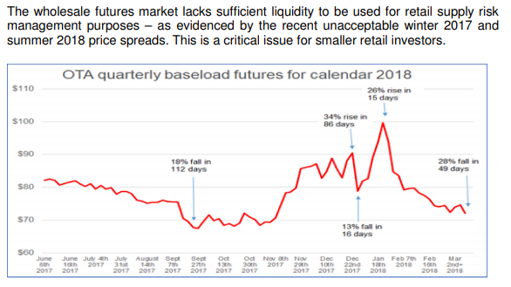

Ecotricity noted in a submission on the Customer Compensation Scheme[33]:

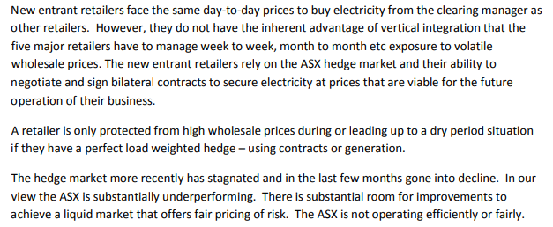

* The volume of trades on any hedge market relative to total physical volumes traded (also known as the churn rate) is an international measure of the liquidity or success of a hedge market to support risk management. According to Ofgem “a higher churn indicates that it is easier for participants to trade and that they are often re-trading in order to optimise their positions before final delivery”. [34]
* The following graph compares New Zealand’s electricity futures market traded on the ASX with the Australian electricity hedge market – also traded on the ASX. Data for the PJM[35] market in the US is also included. This market is highly competitive and referred to by the Electricity Authority as an exemplar.[36]
* Similarly, data from Ofgem in Britain shows monthly churn rates averaging between two to five times physical volumes – not as high as PJM, but similar to Australia and well above New Zealand.

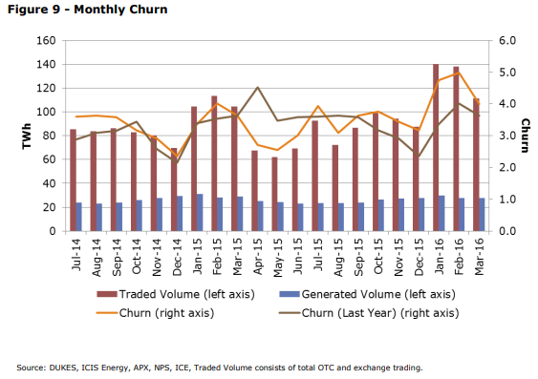

### Figure 9 – Monthly churn of trades in Britain

### Source: DUKES, ICIS Energy, APX, NPS, ICE, Traded Volume consists of total OTC and exchange trading.

### igure 13 – Bid-offer spreads

Ofgem comment on the data:

*“Our data shows an overall higher year-on-year trend in churn. This was positive for liquidity as it shows there may have been more participants willing to trade and hedge their positions in the market.”*

* Another important signal of the success of a futures market is the spread between the buy and sell prices. The Panel’s issues paper[37] acknowledges this:

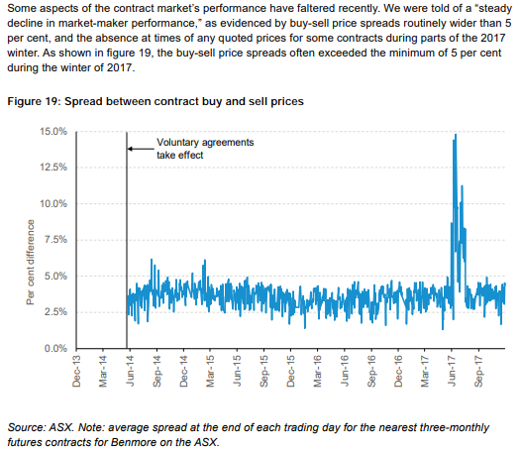

**Figure 19 – Spread between contract buy and sell prices**

Source: ASX. Note: average spread at the end of each trading day for the nearest three-monthly futures contracts for Benmore on the ASX.

## Bid-offer spreads

The same Ofgem report[38] describes the importance of tight spreads and analyses bid-offer spreads in the UK market:

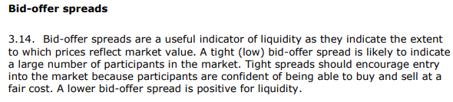

### Figure 13 – Bid-offer spreads in Britain

Source: ICIS Energy

Ofgem comment on the data:

*“Spreads have stayed largely stable over the last year, reflecting the mandated spreads under Secure and Promote. These maintained spreads are positive in that the market can have confidence that prices reflect the underlying demand and supply conditions.”*

* Comparing the two charts above it is apparent that – even leaving aside the spike in winter 2017 – New Zealand’s bid-offer spreads are far higher (by a factor of around 10) than spreads in the British market. While this in part reflects the introduction of compulsory market-making obligations in Britain (with regulated bid-offer spreads), even prior to this, spreads were significantly narrower in the market. Again, this suggests problems with the liquidity and performance of the New Zealand contract market.
* Further, the volume of contracts traded on the ASX market (liquidity) has plateaued or declined in recent times. ENA notes the Panel’s issues paper[39] conclusion that “*some aspects of the contract market’s performance have faltered recently*”.
* According to one retailer, the issue is that “the hedge market pricing appears to be too high relative to retail pricing. Retail pricing should be higher than wholesale because there is more volume uncertainty (risk) and more credit risk”.
* A letter from The Alliance of Independent Retailers to the Electricity Authority (May 2017)[40] focused on the differential between ‘Fixed Price Variable Volume’ (FPVV) retail contracts and the ASX futures ‘Fixed Price Fixed Volume’ (FPFV) contract. There are numerous reasons why the price in a FPVV contract should be priced at a margin above a FPFV ASX contract, namely:

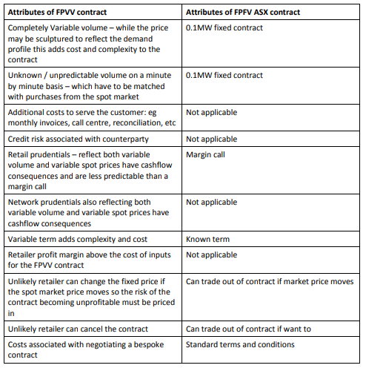

* The Electricity Authority reviewed[41] 1,850 FPVV contracts covering January 2013 to December 2019 in comparison to the ASX settlement price for base-load quarterly contracts at the time the contract was quoted to the customer. This investigation revealed that 12% of these FPVV contracts were priced *below* ASX prices. That is, the six large vertically integrated gentailers were offering commercial and industrial consumers a price below the price paid by a non-vertically integrated retailer to buy this electricity for on-sale.
* The Electricity Authority dismissed this outcome as not requiring any further work. As such, there was no analysis of whether this undercutting was by one only or a number of retailers, or if it was a recent development (given the contract dates covered six years).

MBIE should use the information collected by the Authority to investigate the FPVV contracts priced at or below ASX. As discussed above FPVV contracts should be priced at a margin above ASX contracts.

* According to one retailer, the key issue in the wholesale market is the lack of an incentive for retailers to provide futures contracts and therefore liquidity. “*Gentailers are not excited about being forced to bid into the futures market. If you want competition, the market needs good regulation”.*
* Fundamentally, the issue here is that having a liquid hedge market allows competition in parts of the value chain (either generation or retailing) that competes with the gentailer’s vertically integrated model. The less hedge market liquidity exists, the less competition they face. So gentailers are incentivised to do the minimum amount that fends off any regulatory action to provide liquidity.
* It is worth noting that the current market-making obligations are voluntary. Contact, Genesis, Mercury and Meridian reluctantly agreed to perform the market-making service when the Electricity Authority threatened to make a Code amendment requiring them to do so. Over recent years they have increasing stopped market-making whenever the market becomes tight. This has led to ASX liquidity and trading stagnating over the last two years, and even starting to decline.
* If no action is taken, it’s likely that hedge market liquidity, and the retail competition that depends on it, will decline in coming years.

## Recommendation 4.3: That the Panel recommends resolving long-running concerns about liquidity in the wholesale electricity market and that improving the depth and resilience of the contract market should be given higher priority.

1. **What are your views on the assessment of generators’ and retailers’ profits?**

* It is difficult to assess generator and retail profitability given the current transparency and disclosure by vertically integrated incumbents.
* All electricity distribution companies adhere to a comprehensive information disclosure regime. However, information disclosed by the competitive sector is less transparent or uniform.
* The listed gentailers are subject to accounting standards that require ‘segment reporting’. However, each company treats this obligation differently.
* For example, Meridian Energy[42] reports on its New Zealand electricity generation and electricity retail business to the EBITDAF level:

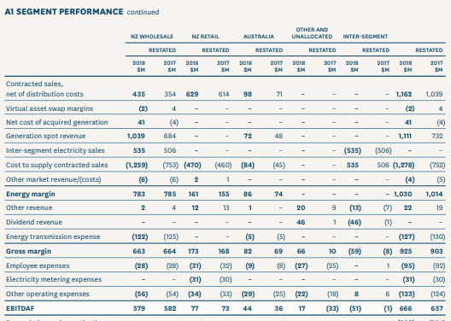

* Mercury reports[43] on ‘Energy Markets’ and Other – providing no split between electricity generation and retailing profitability.

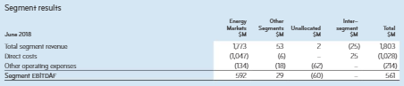

* Genesis Energy[44] combines electricity with gas and LPG for its Customer and Wholesale segments:

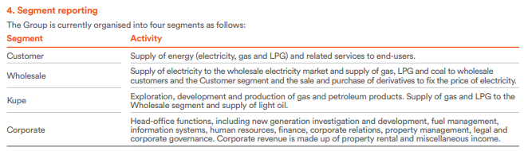

* Contact Energy[45] reports as follows:

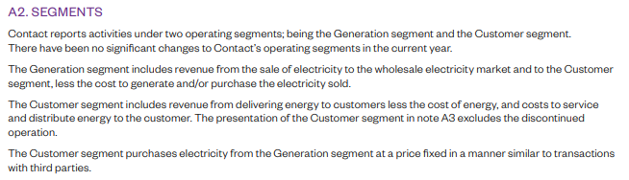

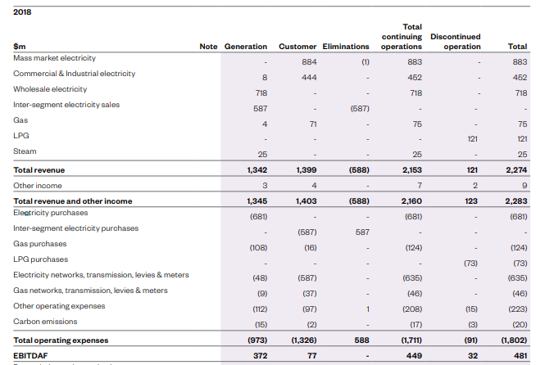

* Trustpower[46] reports as follows:

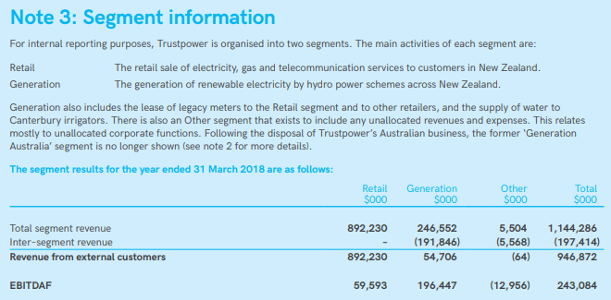

* Small retailers have pointed out that there is a lack of transparency in both the generation and retail segments. This lack of transparency leads to suspicions that the profitable generation unit of a gentailer’s business is used to subsidise lower margins on the retail side. Pure retailers do not have the option to cross subsidise.
* According to one retailer “*We need to know how much money is made in each part of generation and retailing, and the wealth transfer. If competition is hot, they can increase costs in generation, and lower retail margins.*”
* While retail and wholesale activities include some other activities, the following simplistic analysis reveals that wholesale /generation profitability provides a significant buffer to support retail activity for all gentailers based on results for the 12 months ended in 2018[47]. Generation-related activities contribute on average 84% of total EBITDAF:



* The lower ratio of generation EBITDAF to total EBITDAF for Genesis reflects the company’s position as the largest electricity retailer, and reports include retailing of other products such as gas and LPG.

## Recommendation 4.4: That the Panel notes concerns raised about gentailer transfer pricing, and promotes solutions to improve transparency of generator and retailer financial reporting.

**Transmission**

1. **What are your views on the process, timing and fairness aspects of the transmission pricing methodology?**

## Recommendation 4.5: That the Electricity Authority seeks pragmatic solutions that will enable it to complete its review of the transmission pricing methodology as soon as possible.

**Distribution  
20. What are your views on the assessment of distributors’ profits?**

* ENA agrees with the assessment of distributor profits.
* The key point is that distributor prices are regulated by the Commerce Commission, and EDBs must meet minimum quality standards. From 2020, EDB revenues will be regulated.
* Overall, Part 4 regime of the Commerce Act is working adequately. The regime is quite new (introduced in 2008) and there are still wrinkles to iron out, but overall it does the job it set out to do.
* ENA also points out that, in 2017, $402 million was passed on by EDBs to consumers, communities and private shareholders. (2016: $422m, 2015: $402m)[48].
* Of this, in 2017, $216m was provided directly to consumers through discounted prices, dividends to consumer trusts or rebates (2016: $231m, 2015: $224m).
* In addition, in 2017, $87m was contributed to community trusts and local councils (2016: $93m, 2015 $82m).
* ENA does not agree with stakeholders who allege there is potential for distributors to cross-subsidise a competitive business with their own monopoly network business.
* The Commerce Commission and Electricity Authority are both aware of this issue. The Commission recently said that EV chargers outside of depots could not be included in regulated asset bases. And the Commission recently called in more information to help it make further decisions about EDB investments in new network technologies.
* Meanwhile the Commission in April 2018 substantially strengthened its related-party transaction rules on the accounting treatment and required disclosure of unregulated verses unregulated activities.

1. **What are your views on the assessment of barriers to greater efficiency for distributors?**

#### Price Structures

* The distribution industry agrees that its pricing structures need to be modernised and has already started down that path. But pricing reform must be managed carefully to mitigate the negative impact on some consumers, especially less informed or engaged consumers and consumers in energy hardship.
* The ENA published a [substantial paper looking at the options for reform in 2017](https://www.ena.org.nz/dmsdocument/151), and its members prepare six-monthly roadmaps for the Electricity Authority.
* Members are collectively and individually testing different ways to charge for network services so consumers have incentives to use electricity in ways that will save them money immediately, and also over the longer term.
* Changes must be supported by consumers, and other important stakeholders such as electricity retailers. That’s why discussions on pricing reform need to focus on the end consumer and encourage consumers’ active participation around new pricing options. Pricing reform must not be dictated by economic theories, as the impacts on people are more important.
* For clarity, revamped pricing options are sometimes called service-based or cost-reflective tariffs, and include demand, capacity and time-of-use pricing methods, or various combinations of pricing methods that best suit the network and the consumer.
* While the sector is committed to new pricing methods, there are issues and challenges to overcome. These include impacts on consumers (and, in particular, those in energy hardship), data transfer, transmission pricing, billing, technical challenges, and the Electricity (Low Fixed Charge Tariff Option for Domestic Consumers) Regulations 2004. The rural/urban cross subsidy is another complicating factor.
* The biggest change to distribution pricing for 100 years needs to be undertaken with a high degree of care and consideration. Wanting measured progress, members will likely be making decisions about new pricing options after April 2020, with rollout over the following few years.
* Introduction of new pricing options does not mean that all customers will be switched to the new pricing methods on 1 April, 2020. Many ENA members will be phasing the introduction to all customers from that date.

## Recommendation 4.6: That the Panel recommends that EDBs commit to introducing modified distribution pricing options as soon as practicable. This will be dependent on:

* **The government having revoked the Electricity (Low Fixed Charge Tariff Option for Domestic Consumers) Regulations 2004 (refer recommendation 5.3);**
* **That the metering equipment (i.e. smart meters) necessary to support these new tariffs is installed, and associated consumption data is available;**
* **Effective customer engagement, and retailers supportively passing new distribution charges to their customers.**

#### Business Size

* ENA does not have a view on the ‘right’ number of EDBs.
* Any voluntary decision to reduce the number of EDBs would be made by the network owners, which are mainly trusts and councils.
* Averaged nationally, New Zealand has one EDB per 174,000 people.
* Germany, with a population of 82 million, has 800 EDBs, or one per 102,000 people[49]
* Norway, with a population of five million, has 148 distribution companies, or one per 34,000 people.
* Finland, with 5 million people, has 89 EDBs, or one per 56,000 people.
* On the other hand, Australia, with 24 million people, has 15 EDBs, or one per 1.6 million people.
* The UK, with a population of 65 million, has seven EDBs (14 networks), or one per 6 million.
* The 2017 IEA report into New Zealand’s electricity sector recommended amalgamations among smaller EDBs, in the name of more effective management.
* However, the report also stated that “no official empirical analysis has been undertaken on economies of scale in New Zealand’s distribution businesses, and there is little evidence that small firms are less innovative or perform less well than large ones”.[50]
* Countering the IEA’s recommendation, George Yarrow of the Regulatory Policy Institute, Oxford, UK, notes however there is extensive evidence from many studies of pre- and post-amalgamation performance of businesses that post-amalgamation performance is very frequently disappointing relative to prior expectations, and quite frequently is worse.[51]

1. The most directly relevant evidence is provided in research undertaken by Professor Michael Pollitt focused on mergers between electricity distribution companies.

* In his paper co-authored with John Kwoka (2014)the authors analysed the performance impact of the merger wave which took place in the US electricity industry during the period 1994-2003.[52]
* The results indicated that electricity mergers were not consistent with improved cost performance.

1. In a study by Adonis Yatchew[53], the performance of 81 municipal distributors in Ontario, Canada, over the three years from 1993 to 1995 was analysed. The distributors ranged in size from around 600 to 220,000 customers.

* Yatchew, in summarising a number of similar studies that included New Zealand, Norway and Switzerland as well as Ontario, notes that “minimum efficient scale occurs at surprisingly small scales of operation [>4,000 connections].”
* The studies have found “no convincing evidence of significant economies of scale in electricity distribution, other than at very small scale” (Yarrow, 2018).
* A report undertaken by TDB Advisory in the New Zealand context supports that conclusion. Density (in terms of consumer connections per kilometre of network) is a greater indicator of efficiency than scale.
* In summary, ENA does not have a view on what number is the ‘right’ number of EDBs. Greater size does not necessarily translate into greater efficiency – but similarly there can be economies of scale achieved from rationalisation of ownerships.
* ENA members frequently collaborate and cooperate on network operations.  
  A detailed list of collaboration and cooperation examples has been provided to the Panel.
* Briefly, these examples include collaboration through industry associations including the Electricity Networks Association, storm and emergency response, shared services, procurement, technical standards, health and safety frameworks, and metering and cyber-security collaboration.
* Collaboration among EDBs is both extensive and extremely productive. ENA rates the current level of collaboration as at least nine out of ten – allowing for good on-the-ground local knowledge and community ownership blended with the efficient use of shared resources and services as required. Pleasingly, this collaboration has developed ‘organically’ and willingly, and has not been imposed by regulations or centralised control.

#### Meter data

* We agree with the Panel’s conclusion that metering data should be readily available on reasonable commercial terms so distributors can properly manage their networks, including making decisions about maintenance and upgrades and managing power outages more promptly.
* EDBs also require access to smart meter consumption data to enable the deployment of revamped pricing options. EDBs recognise that the protection of consumers’ data is of paramount importance and would ensure such data is managed appropriately and securely.
* ENA also supports the suggestion of an open-access regime for meter data with standardised terms and conditions for all parties. This would involve meter data being sent to data processors or aggregators which send it to those who request it – mainly retailers and distributors.
* It is important that the terms for access to network data, are such that EDBs, and by extension consumers, can receive the benefits from this data which would otherwise be forgone. Access to consumption data is also important to enable revamped distribution pricing.

## Recommendation 4.7: That the Panel recommends an open access regime for smart meter data (i.e. consumption and network data) with standardised terms and conditions, subject to commercial agreement between all parties.

#### Asset management and planning

* ENA is aware of concerns raised around long-term asset planning.
* EDBs each year prepare and publish a formal ten-year asset management plan (AMP), which is a sufficiently long and effective public planning horizon.
* In addition to documented AMPs, EDBs also carry out long-range planning and strategic analysis for governance discussions. It would be incorrect to say that no thought is put into asset planning beyond the ten-year window of the AMP.

#### Ageing assets

* Some EDBs are facing a period in the short- and medium-term planning horizon which will require decisions on significant asset upgrades.
* These assets installed in the 1960s and 1970s now require replacement. Most EDBs are managing this maintenance and investment through default price paths. However, others with significant spending requirements have the option of applying for a customised price path.
* So far there has been two ‘ordinary’ CPP approvals (the first, for Orion, was extraordinary because it stemmed from the Christchurch earthquake). At least one more CPP (Aurora) is in the planning stages.

1. **What are your views on the assessment of the allocation of distribution costs?**

**Business versus residential**

* We agree with the Panel that there could be merit in a discussion or review of how costs are allocated between residential and non-residential consumers.
* That said, ENA members have raised questions about the Concept Consulting study on allocation.
* The study and the Panel are suggesting that residential customers are paying more of shared costs than they should, and commercial is paying less.
* Network pricing allocation differs across EDBs so it is difficult to make this general conclusion at this time.
* ENA notes that the introduction of new pricing methods such as capacity, demand, or time-of-use pricing, should result in shared costs being apportioned fairly across customer groups.
* As acknowledged in the Concept Consulting analysis, some EDBs do not have a residential group of customers – load groups may instead simply be defined on the basis of capacity. Many small businesses are in the same low load groups as households. This makes clean comparisons between residential and non-residential customers problematic but not impossible.
* Concept undertakes a set of calculations which involve:
* estimating incremental and standalone costs for residential and business customers based on a series of assumptions, and then;
* calculating the implications of alternative approaches to allocating shared costs, one of which involves allocating shared costs mid-way between incremental and standalone costs and the other where 100 per cent of shared costs are allocated to business customer. The shared costs estimated by Concept includes not only non-network shared costs, but also a portion of network costs.
* On this basis, Concept concludes that network charges could fall by 11% for residential connections, leading to a 4.5% (or $90 per annum) reduction in retail bills for residential customers, with network charges increasing by 13% for business customers, translating to a 5.5% increase in business customer retail bills. Concept also presents an extreme result where all shared costs are allocated to business customers, which it finds may increase business network charges on average by 54% (increasing the average business retail bill by 23.5%) and would reduce average residential network charges by 46% (reducing the average residential retail bill by 17.5%).
* The ENA appreciates that these are only indicative estimates of potential changes in charges as a result of a revised allocation methodology. Consequently, we have not provided a full evaluation of the assumptions and calculations in this submission. However, in the ENA’s view, this analysis is not particularly helpful in identifying whether a problem exists and, if so, the potential cause of the problem and the most appropriate solution.
* All EDBs are required to publish a pricing methodology each year which, among other things, sets out how the distribution revenue requirement is allocated to individual load groups for the purposes of determining prices. A review of these methodologies would have revealed a number of factors that contribute to the cost allocation outcome for residential and business customers, including the allocation methodologies adopted and the usage profiles of the customer base.
* Importantly, the review would also have found that EDB allocation methodologies usually reflect the network service provided and the usage or demand characteristics of the load groups. For example, low voltage (LV) costs are generally allocated to load groups that use the LV network, usually on the basis of some measure of capacity or demand. This means an LV customer with particular usage characteristics will be allocated exactly the same level of costs, regardless of whether they are defined as residential or business.
* In contrast, the Concept approach could result in a different level of distribution costs being allocated to customers using exactly the same network service simply on the basis of whether they are defined as residential or business. In the ENA’s view, the Concept approach is largely arbitrary and has the potential to lead to extreme and potentially inefficient results.
* Notwithstanding the difficulties with the Concept analysis, the ENA does believe there is potential for improvement in the allocation methodologies adopted by EDBs, which could lead to reduced bills for residential customers. However, these improvements should be based on a clear understanding of what is driving the current outcomes and the implementation of changes that will lead to more efficient and equitable outcomes.
* In the ENA’s view, careful consideration also needs to be given to the implementation of any changes, as large immediate changes could compromise the competitiveness of New Zealand businesses, whereas if timed more carefully, reductions in residential bills could be delivered with minimal impact on business customers.
* The ENA proposes that a working group of EDBs is established to develop a common approach to distribution cost allocation, including an implementation program, which will deliver a more efficient and equitable allocation of distribution costs.

## Recommendation 4.8: That the Panel recommends EDBs carry out a review, with support from ENA, to examine cost allocation, to determine if residential consumers are being allocated a fair share of non-network or shared costs under their existing pricing methodology. The output of review(s) should be made publicly available.

**Urban-Rural cross subsidy**

* ENA disagrees with the assertion in the issues paper that the urban consumer subsidy of rural consumers “does not stand up to scrutiny…”.
* We would note that the above view appears to be at odds with a later statement that “forcing the use of urban-rural pricing would make it even harder for rural low-income consumers to pay their electricity bills”.
* ENA believes it is highly probable that rural consumers are subsidised by urban consumers in some networks, simply due to a lack of discrimination between these classes of consumer. We would like to see further analysis carried out by the Panel to support its assertion quoted above.
* We expect individual ENA members will make submissions on this point, which is very pertinent to allocation of distribution costs.

1. **What are your views on the assessment of challenges facing electricity distribution?**

* The ENA agrees with the Panel’s discussion on capability and skills. ENA members are reporting difficulties finding qualified technicians.
* This is concerning because members are expecting to be requiring skills for upgrading assets which were installed in the second half of the twentieth century.
* Network companies also require capability to prepare their distribution assets for an expected upsurge in electricity consumption due to decarbonisation of the economy and consumer demand for new technologies (e.g. EVs).

## Summary of feedback on Part four

|  |  |
| --- | --- |
|  | **Please summarise your key points on Part four.** |

* Despite the growing number of small and new-entrant retailers in the New Zealand electricity retail market, collectively these businesses only hold a very small fraction of the retail market. Many stakeholders have queried whether there is a level playing field for these new entrants.
* ENA agrees with the Panel’s assessment that there is a ‘two-tier’ electricity retail market operating in New Zealand, characterised by the difference in price paid by consumers who switch and those who do not.
* Overseas jurisdictions (notably Britain) have experimented with various interventions to attempt to reduce the two-tier electricity market they have.
* There are indicators that suggest problems with the liquidity and performance of the New Zealand contracts market.
* The lack of transparency in generator and retailer profitability makes it difficult to assess with any degree of accuracy.
* ENA agrees with the Panel’s assessment of distributor profits.
* Distributors are working with the Electricity Authority and other stakeholders (e.g. retailers) to modernise their pricing structures. However, this must be handled with care to ensure that the impacts on ensuing ‘losers’ from any price reform are minimised, and consumers are supported appropriately.
* ENA does not have a view on the ‘right’ number of distributors, and we not believe significant gains to efficiency (and therefore cost savings) would be brought about by amalgamation of EDBs.
* EDBs collaborate, both through ENA and bilaterally, across a number of activities and business areas, where it is sensible to do so.
* ENA agrees with the Panel that there may be merit in reviewing distribution cost allocation methods to ensure that the allocation of shared costs between residential and non-residential consumers is fair.
* ENA nevertheless has some concerns about a Concept Consulting analysis included in the Panel’s issues paper. The year 2000 would have been a more sensible and comparable starting point.
* ENA believes that there is more substance to the issue of urban to rural consumer cross-subsidies than the Panel suggests in its report.
* ENA and EDBs are aware that in the future EDBs will require a broader set of skills and capabilities within their organisations than has historically been the case. This may pose challenges to achieve.

## Solutions to issues and concerns raised in Part four

|  |  |
| --- | --- |
|  | **Please briefly describe any potential solutions to the issues and concerns raised in Part four.** |

* That the government or the relevant regulator carry out further research and data analysis into the ‘two-tier’ market of consumers, including the characteristics of consumers who switch and don’t switch, and review solution options used successfully overseas.
* ENA acknowledges concerns that ‘saves’ and ‘win-backs’ are an impediment to full and effective retail competition and consumer switching. We recommend and support the Electricity Authority’s continuing investigation into the practice.
* That the Panel recommends resolving long-running concerns about liquidity in the wholesale electricity market and that improving the depth and resilience of the contract market should be given higher priority.
* That the Panel notes concerns raised about gentailer transfer pricing, and promotes solutions to improve transparency of generator and retailer financial reporting.
* That the Electricity Authority seeks pragmatic solutions that will enable it to complete its review of the transmission pricing methodology as soon as possible.
* That the Panel recommends that EDBs commit to introducing revamped distribution pricing options as soon as practicable. This will be dependent on:
  + The government having revoked the Electricity (Low Fixed Charge Tariff option for Domestic Consumers) Regulations 2004 (refer recommendation 5.3);
  + That the metering equipment (i.e. smart meters) necessary to support these new tariffs is installed, and associated consumption data is available;
  + Effective customer engagement, and retailers supportively passing new distribution charges to their customers.
* That the Panel recommends an open access regime for smart meter data (i.e. consumption and network data) with standardised terms and conditions, subject to commercial agreement between all parties.
* That the Panel recommends ENA members carry out a review, with support from ENA, to examine cost allocation, to determine if residential consumers are being allocated a fair share of non-network or shared costs under their existing pricing methodology. The output of these reviews will be made publicly available.

## Part five: Technology and regulation

## Technology

1. **What are your views on the assessment of the impact of technology on consumers and the electricity industry?**

* ENA broadly agrees with the Panel’s assessment[54] of the types of technologies that are likely to be available and adopted by consumers in the medium-to-long term.
* These technologies, which include solar PV, electric vehicles, charging infrastructure, and domestic and commercial-scale batteries, and the markets that may develop to support them, are mostly still at an early stage of deployment but are advancing rapidly. It is vital that EDBs are permitted to invest in testing, trialling and deploying these technologies. EDB involvement will uncover opportunities and benefits for network operation and maintenance, and for consumers. EDBs will enable technology deployment on a wide scale with minimum cost and disruption – including to network reliability – and maximum benefit to consumers.

1. **What are you views on the assessment of the impact of technology on pricing mechanisms and the fairness of prices?**

* ENA agrees with the Panel’s assessment of the impact of technology and pricing mechanisms and the fairness of prices. EDBs are already in the process of considering how best to reform their prices, not just to achieve cost-reflectivity, but also to meet the needs and expectations of consumers.

1. **What are your views on how emerging technology will affect security of supply, resilience and prices?**

* ENA agrees with the Panel’s assessment[55] of the potential impacts of emerging technology on security of supply, resilience and prices. In particular, we strongly agree with the Panel’s concluding remark that *“Careful management of change should ensure no risk to the electricity system’s resilience and ability to perform reliably”[56]*. EDBs are well aware of the risks posed by uncoordinated mass deployment of emerging technologies, and are working to better understand and plan for these impacts.
* Risks could be mitigated by EDBs gaining better visibility of power flows on low voltage networks. This could be achieved through improved access to information generated by smart meters or equivalent technologies (i.e. other forms of network monitoring technologies).
* For this reason, it is important that retailers complete the roll out of smart meters in all parts of New Zealand. In some areas (e.g. Eastland, Westpower, Marlborough Lines) only half of customers have smart meters.
* It is important to note that distribution pricing reform discussed in question 27 will be an important factor in ensuring that networks are used as efficiently as possible (e.g. using pricing to encourage load shifting), which will help guard against network over-capacity and associated reliability issues.

## Recommendation 5.1: That the Panel strongly encourages deployment of smart meters to as many New Zealand consumers as practicable.

**Regulation**

1. **What are your views on the assessment of the place of environmental sustainability and fairness in the regulatory system?**

* Electricity is an important way of increasing the sustainability of the broader energy sector and EDBs are supportive of government’s efforts to encourage electrification of transport through greater use of fully-electric cars and busses.
* ENA agrees with the Productivity Commission[57] (also referenced in the Panel’s report), that introducing additional costs to the electricity industry, with the aim to increase efforts to decarbonise the sector, may have the unintended and undesirable effect of hindering efforts to decarbonise other parts of the economy.
* ENA believes that the New Zealand Emissions Trading Scheme is the appropriate way for the government to encourage economy-wide decarbonisation at the lowest possible costs, and environmental sustainability objectives should not be a feature of the New Zealand electricity regulatory framework, except through the ability for EDBs to participate in seeding markets and carrying out trials/research and development to enable emerging technology for the benefit of consumers.

## Recommendation 5.2: That the Panel recommends the New Zealand Emissions Trading Scheme is the appropriate way for the government to encourage economy-wide decarbonisation at the lowest possible costs.

1. **What are your views on the assessment of low fixed charge tariff regulations?**

* The ENA has long-established position on the low fixed charge tariff regulations.
* In the interests of brevity, the views of ENA and the Electricity Retailers Association of  
  New Zealand are summarised in a document available [here.](https://www.ena.org.nz/news-and-events/news/why-the-low-fixed-charge-regulations-should-be-removed/)
* ENA agrees with the Panel’s issues paper that the regulations should be revoked, and we would add that this should be a matter of urgency. In addition to creating an unfair cross-subsidy, the regulations severely inhibit distribution companies and retailers from developing and offering new and innovative prices for consumers. Over the longer term, and particularly with new consumer-level technologies coming onstream, the regulations will restrict consumers’ ability to benefit from these new technologies.
* ENA members understand that the removal of the regulations and adoption of new pricing methods will result in benefits for some bill payers, but for others, there will be some upward adjustment. This is especially the case for consumers who might have high loads for short periods, and low loads for long periods.
* ENA is aware of these impacts and is working to understand them to help members manage a transition toward removal of the regulations and cost-reflective pricing.
* ENA has in recent years been talking to stakeholders to seek support for the removal of the low-fixed charge regulations. Grey Power continues to oppose their removal and this discussion is ongoing. We would note that the $700 winter energy payment to all superannuitants applying fully in 2019 would exceed any increases in bills due to the removal of the low-fixed charge regulations.

## Recommendation 5.3: The ENA recommends that the Electricity (Low Fixed Charge Tariff Option for Domestic Consumers) Regulations 2004 should be revoked as a matter of urgency. ENA and EDBs are willing to commit to lead a process, with government and other industry participants (e.g. retailers), to design mechanisms to mitigate any negative impacts of this transition.

1. **What are your views on the assessment of gaps or overlaps between the regulators?**

**Regulation of networks**

* ENA members have identified benefits in shifting all economic, pricing, and reliability regulation of networks to the Commerce Commission. This rationalisation of functions would clear confusion for network companies and stakeholders, and reduce the workload on the Authority, thereby allowing it to concentrate on dealing with the significant issues in the market that have been raised by the Panel.
* The Electricity Authority would remain in charge of oversight of issues concerning generation, retailing, and the wholesale electricity market, while any areas concerning networks would rest with the Commission.
* ENA believes that a reallocation would not only clarify the roles of the two regulators, it would create a defined boundary between them and, by definition, clearer delineation of roles.  The Panel itself has identified some issues of overlap and ambiguity in areas such as network procurement, competitiveness of adjacent markets, and access to distribution networks.
* A single regulator for distribution (and possibly transmission, though ENA does not have a view on this) would leverage the skills and experience of the Commerce Commission, which is the expert in regulation of monopoly networks and infrastructure.
* The Commission has well-established processes for consultations with the distribution sector, and, by and large, carries out these consultations in a fair and measured way.  For example, the Commission spent two years preparing and consulting on the review of input methodologies, breaking the consultation into bite-sized pieces.  More recently, the Commission has been working with the ENA well ahead of the 2020 reset of the Default Price Path.
* Moving the Electricity Authority’s pricing oversight to the Commission would also send an encouraging message to investors. The Commission has set input methodologies which have been through a seven-year review, creating a stable regulatory environment. “The creation of a stable regulatory environment has been recently confirmed through an independent assessment by Standard & Poor’s Global. Improved credit ratings should feed through to consumers through our assessment of the debt premium from corporate bonds and lead to lower prices. We have estimated that approximately $6 billion has been invested by electricity lines businesses since 2008 and that investment is still an important driver of consumer benefits in this sector.”[58]

**Access to Networks**

* In regard to the Panel’s comments about regulatory overlap in terms of access to networks, ENA does not agree that there is a clearly defined problem with access to networks.
* The EPR issues paper describes what appears to be entirely theoretical concerns about situations that might arise in the future related to the deployment of new technologies on the distribution networks and the commercial opportunities that could arise.
* As noted in ENA’s response to question 26 above, we believe it would be premature to curtail EDB investment and deployment of new technologies. To do so would inhibit or curtail the types of new technology-driven markets and offerings that the industry and Government are trying to encourage. We strongly recommend to the Panel that no regulatory intervention be made while these markets are still emerging. If and when concrete, real-world evidence emerges of some negative effect on new markets due to EDB interaction, it would then be reasonable to reassess the regulations around ‘network access’.

## Recommendation 5.4: That the responsibility for the regulation of any matters related to electricity distribution should be transferred from the Electricity Authority to the Commerce Commission.

## Recommendation 5.5: That no regulatory intervention be made while markets enabled by new technologies (e.g. PV, electric vehicles and charging infrastructure, domestic and grid-scale batteries, etc) are still emerging. If and when concrete, real-world evidence emerges of some negative effect on new markets due to EDB interaction, it would then be reasonable to reassess the regulations around ‘network access’.

1. **What are your views on the assessment of whether the regulatory framework and regulators’ workplans enable new technologies and business models to emerge?**

* ENA agrees that the specific example (peer-to-peer trading) quoted by the Panel[59] is not facilitated easily by the current regulatory framework. But the EA has a work programme to address this particular issue.
* Leaving aside the peer-to-peer example, ENA does have concerns that the ability of industry regulators (and wider government agencies) to amend third-tier rules, and primary and secondary legislation to accommodate rapid technological change, is significantly limited.
* For example, the industry is frustrated by the extremely slow processes for technical standards, referenced in regulations, to be updated in a timely manner. We urge the Panel to recommend that the regulatory framework be reviewed to ensure that changes to standards and other codes and guidance can be made in a timely way so these do not pose a barrier to technology uptake or business innovation.

## Recommendation 5.6: That the Panel recommends that the regulatory framework supports the ability to improve standards, codes and guidance in a timely way, to avoid barriers to technology uptake or business innovation.

1. **What are your views on the assessment of other matters for the regulatory framework?**

* Because it is not mentioned in the Panel’s issues paper, ENA draws the attention of the Panel to the issue of the Electricity (Hazards from Trees) Regulations 2003 (the tree regs).
* Management of vegetation close to overhead powerlines, and the costs of repairing overhead lines damaged by vegetation, are very significant sources of expenditure for some EDBs. The antiquated, bureaucratic and inflexible nature of these regulations hamstring EDB efforts to undertake a more modern, risk-based and strategic approach to managing vegetation close to their assets.
* The existing regulations place too small a burden on commercial tree owners (i.e. plantation forest owners) who should be managing the safe planting of their trees without relying on EDBs to manage them, which ultimately moves the cost of those activities onto EDB consumers.
* The tree-related costs can vary depending on the nature of the network and the amount of vegetation in the area, but can be as high as $120 per consumer connection per annum.
* ENA has been requesting MBIE review the tree regs for some time with a view to modernising them and making them more outcomes-focussed and less prescriptive. We believe these costs could be reduced and service reliability improved, perhaps significantly, if the tree regs are reviewed and updated to empower EDBs to make decisions about where best to spend limited resources on vegetation management.
* Another long-standing concern is the uncertainty around customer service lines, which are privately-owned lines typically stretching from a power pole outside the property to the bargeboard of a consumer dwelling. In a rural context, customer lines could stretch for many hundreds of metres, or kilometres, and include power poles on private land.
* As these assets are often not maintained to a proper standard, there is a growing risk that they will cause harm to people or farm animals[60], or damage to property.
* The government needs to review urgently the legislation or regulatory settings to improve the reliability and safety of customer lines. Ownership, awareness, and EDBs’ roles in maintaining customer lines should be reviewed to ensure that an outcome is reached which results in proper maintenance of these assets and improves the safety of workers and consumers.

## Recommendation 5.7: That the Panel supports a review of the Electricity (Hazards from Trees) Regulations 2003 which results in more effective methods of managing vegetation at risk of disrupting electricity supply, and reduces network operating costs (and therefore consumer bills).

**Other Matters**

**On page 79 of the issues paper, the EPR invites views on a range of other regulatory-related points, which ENA will comment on in turn:**

**Consumer voice – difficult for ordinary consumers or consumer advocacy groups to participate in regulatory consultation processes, including judicial or merits reviews.**

* ENA agrees that the ordinary consumer struggles to have a ‘voice’ in a complex sector. This is discussed in part three of this submission.
* Information disclosure is one way for consumers to learn more about the sector, and the regulators have been investing in improved ways of presenting this information in a consumer-friendly format (e.g. dash boards).
* That said, we would note that while EDBs and Transpower are subject to robust information disclosure processes, no comparable level of transparency exists in the generation and retailing sectors.
* Some mechanism by which regular consumers, or consumer representatives, can either inspect or oversee the regulatory processes that apply to those sectors of the market may help to enhance consumer confidence in the industry as a whole.

**Pace of change – too long to change regulatory settings and third-tier rules (e.g. the Code).**

* Agreed – see comments regarding pace of regulatory change under question 32.

**Authority functions – stakeholders say that should separate rule-maker from rule enforcer.**

* See our recommendation 5.4 above.

**Authority decisions – EA decisions should be subject to challenge in the courts?**

* ENA supports the ability for energy sector participants and consumers to challenge the merits of Electricity Authority decisions in the courts. This is the same rule that applies to the Commerce Commission. We would note that, over the past five years, there has been a marked decrease in court action taken by energy companies against the Commission.

**Regulatory costs – EA and ComCom spent $25.6 mil on regulatory functions – thoughts?**

* We refer you to our answer to question 30 above.

**Input methodologies – not minded to re-examine input methodologies, transmission and distribution asset values, and the WACC.**

* ENA strongly agrees with the Panel that, given its assessment that Part 4 and price quality regulation are generally working well, it would be wise to not reopen the input methodologies, transmission and distribution asset values, and the WACC.
* These items have been reviewed by many parties and subject to the consideration of the courts. It is unlikely that a review by the Panel, given time and resource constraints, could recommend changes to these rules that would materially improve these processes, and the scope for well-intentioned but ultimately damaging changes is large.

## Summary of feedback on Part five

1. **Please summarise your key points on Part five.**

* New technologies are becoming increasingly available to consumers that will fundamentally alter the way they interact with the electricity system and wider electricity market.
* EDBs play an important role in stimulating and supporting the uptake of these new technologies.
* These emerging technologies are potentially a risk to security of supply, reliability and pricing, and EDBs are working collectively and individually to manage these risks. Better visibility of low-voltage networks, via access to network-related smart meter data, would be a significant help.
* Revamped distribution pricing will also help mitigate some of these risks.
* The government should be mindful that any increased costs in the electricity system could be a barrier to electrifying sections of the economy (e.g. process heat, electric vehicles) in pursuit of wider decarbonisation objectives. The New Zealand Emissions Trading Scheme is the best mechanism for the government to achieve its decarbonisation targets at lowest cost.
* The Electricity (Low Fixed Charge Tariff Option for Domestic Consumers) Regulations 2004 should be revoked, but EDBs are willing to support a process whereby mechanisms are designed to mitigate the negative effects of change on consumers.
* The regulatory processes to update or amend legislation or technical codes are too slow to match the expected pace of change brought by new technologies.
* The management of vegetation is a significant cost for many EDBs, a cost passed through to consumers. Reform of the bureaucratic and outdated Electricity (Hazards from Trees) Regulations 2003 could vastly improve outcomes in this area – reducing costs and improving security of supply and public safety.

## Solutions to issues and concerns raised in Part five

1. **Please briefly describe any potential solutions to the issues and concerns raised in Part five**

* That the Panel strongly encourages deployment of smart meters to as many New Zealand consumers as practicable.
* That the Panel recommends the New Zealand Emissions Trading Scheme as the appropriate way for the government to encourage economy-wide decarbonisation at the lowest possible costs.
* The ENA recommends that the Electricity (Low Fixed Charge Tariff option for Domestic Consumers) Regulations 2004 should be revoked as a matter of urgency. ENA and EDBs are willing to commit to lead a process, with government and other industry participants (e.g. retailers), to design mechanisms to mitigate negative impacts of this transition.
* That responsibility for the regulation of any matters related to electricity distribution should be transferred from the Electricity Authority to the Commerce Commission.
* That no regulatory intervention be made while markets enabled by new technologies (e.g. solar PV, electricity vehicles and charging infrastructure, domestic and grid-scale batteries, etc) are still emerging. If and when concrete, real-world evidence emerges of some negative effect on new markets due to EDB interaction, it would then be reasonable to reassess the regulations around ‘network access’.
* That the EPR recommends that the regulatory framework supports the ability to improve standards, codes and guidance in a timely way, to avoid barriers to technology uptake or business innovation.
* ENA recommends that the Panel supports a review of the Electricity (Hazards from Trees) Regulations 2003 which results in more effective methods of managing vegetation at risk of disrupting electricity supply, and reduces network operating costs (and therefore consumer bills).

## Additional information

1. **Please briefly provide any additional information or comment you would like to include in your submission.**

No further comments.

1. ENA Consumer Reference Panel report, Aug 2018
2. ENA consumer focus group report, Oct 2017
3. ‘Australian Consumers’ Likely Response to Cost-Reflective Electricity Pricing’, K. Stenner, E. Frederiks et al, CSIRO, June 2015
4. ‘Domestic electricity price components’, PwC report to ENA, July 2017, updated 2018
5. Electricity Price Review Issues Paper, MBIE, September 2018, p23
6. NZIER (2015) *Effects of distribution charges on household investment in solar.* Report to the Electricity Authority  (<https://www.ea.govt.nz/dmsdocument/20059-nzier-effects-of-distribution-charges-on-household-investment-in-solar>), key points, page i.
7. Electricity Price Review Issues Paper, MBIE, September 2018, <https://www.mbie.govt.nz/info-services/sectors-industries/energy/electricity-price-review/consultation/first-report.pdf> Page 35
8. International Energy Agency ‘Energy Policies of IEA Countries – New Zealand 2017 Review’, page 102
9. Ibid, page 67
10. ibid, page 102
11. Ibid, pages 64 and 65
12. This includes the share of subsidiary or ‘challenger brands’ owned by the five incumbent gentailers as all the brands owned by the gentailer benefit from being part of the group
13. Source: <https://www.emi.ea.govt.nz/Retail/Reports/R_MST_C?ParentCompany=N&seriesFilter=&_si=_dr_ParentCompany|Y,v|4>
14. <https://www.ea.govt.nz/dmsdocument/23817-ecotricity> page 3
15. Source:

    <https://www.emi.ea.govt.nz/Retail/Reports/IR0U5M?DateTo=20171231&RegionType=ISLAND_1&_si=tg|residential-savings,_dr_DateTo|20171231,_dr_RegionType|ISLAND_1,v|4>
16. The EPR Report refers to an average saving of around $200 a year (3rd paragraph page 36)
17. Energyclub (owned by Future Energy) submission to MDAG on saves and win backs 24 July 2018 <https://www.ea.govt.nz/dmsdocument/23818>
18. <https://www.emi.ea.govt.nz/Retail/Reports/W4TZQL?RegionType=NWK_REPORTING_REGION&_si=tg|residential-savings,v|3>
19. <http://www.mbie.govt.nz/info-services/sectors-industries/energy/energy-data-modelling/statistics/prices/electricity-prices/documentlibrary/Quarterly%20Survey%20of%20Domestic%20Electricity%20Prices%20as%20at%2015%20November%202013.xlsx>
20. This tariff reflects contracts that are based on evergreen principles, with no end date (and no exit fee), the tariff for which the retailer can change over time.
21. “Retail Lessons for New Zealand from the UK Energy Market Investigation”, Martin Cave, May 2018, Page 6
22. Thwaites, Faulkner & Mulder, “Independent review into the electricity and gas retail markets in Victoria”, August 2017 <https://engage.vic.gov.au/application/files/7415/0267/4425/Retail_Energy_Review_-_Final_Report.pdf>
23. Source: Electricity Price Review Issue Paper, page 39 available at <https://www.mbie.govt.nz/info-services/sectors-industries/energy/electricity-price-review/consultation/first-report.pdf>
24. See <https://www.ofgem.gov.uk/publications-and-updates/ofgem-proposes-price-cap-give-11-million-customers-fairer-deal-their-energy>
25. Ibid page 14
26. <https://www.ofgem.gov.uk/publications-and-updates/eight-times-many-people-get-better-deal-ofgem-s-collective-switch-trial>
27. Thwaites report <https://s3.ap-southeast-2.amazonaws.com/hdp.au.prod.app.vic-engage.files/7415/0267/4425/Retail_Energy_Review_-_Final_Report.pdf>
28. Electricity Price Review Issues Paper, page 35
29. IEA report page 67
30. IEA report page 19
31. Energy News “MARKET UPDATE: Uncertainty, volatility reflected in hedge markets”, 31 August 2018
32. <https://www.ea.govt.nz/dmsdocument/23823-pioneer-energy> page 2
33. <https://www.ea.govt.nz/dmsdocument/21695-ecotricity>
34. <https://www.ofgem.gov.uk/system/files/docs/2016/08/wholesale_power_market_liquidity_annual_report_2016.pdf> page 19-20
35. PJM or Pennsylvania, Jersey, Maryland Power Pool operates a competitive wholesale electricity market in all or parts of Delaware, Illinois, Indiana, Kentucky, Maryland, Michigan, New Jersey, North Carolina, Ohio, Pennsylvania, Tennessee, Virginia, West Virginia and the District of Columbia
36. <https://www.ea.govt.nz/dmsdocument/19225-appendix-a-report-from-monitoring-analytics>
37. <https://www.mbie.govt.nz/info-services/sectors-industries/energy/electricity-price-review/consultation/first-report.pdf> page 44
38. <https://www.ofgem.gov.uk/system/files/docs/2016/08/wholesale_power_market_liquidity_annual_report_2016.pdf> page 23-24
39. Electricity Price Review Issues Paper, page 44
40. <https://www.ea.govt.nz/dmsdocument/23186-letter-from-tair-to-ea-gm-market-performance-pir-of-save-protection-scheme>
41. <https://www.ea.govt.nz/monitoring/enquiries-reviews-and-investigations/2017/review-of-fixed-price-variable-volume-commercial-offers/>
42. <https://www.meridianenergy.co.nz/assets/Investors/Reports-and-presentations/Annual-results-and-reports/2018/95098799a5/Meridian-Energy-Integrated-Report-for-the-year-ended-30-June-2018.pdf> page 91
43. <https://issuu.com/mercurynz/docs/20180821_mercury_annual_report_2?e=25554184/64127255> page 35
44. <https://gesakentico.blob.core.windows.net/sitecontent/genesis/media/new-library-(dec-2017)/about_us/investor/pdfs/2018/full%20year/ge-annual-report-29aug-2018.pdf> page 35
45. <https://contact.co.nz/-/media/contact/pdfs/about-us/investor-centre/media-releases/annual-report-2018-contact-energy.ashx> page 54
46. <https://www.trustpower.co.nz/-/media/Reports/TPL23495-Trust-Power-AR-2018_FA3-WEB_SP.ashx> page 53
47. Balance date of 30 June for Meridian, Mercury, Genesis and Contact and 31 March for Trustpower
48. PWC analysis of electricity distribution business contributions, May 2018
49. Source: Philippe Chanel, *Overview of Electricity Distribution in Europe – summary from Capgemini’s 2008 European benchmarking survey*
50. IEA Review of NZ’s electricity sector 2017, pp 150
51. G Yarrow, Critique of IEA Review of New Zealand for Energy Trusts New Zealand, 2018
52. John Kwoka and Michael Pollitt, *Industry Restructuring, Mergers and Efficiency: Evidence from Electric Power*, EPRG 0708, Cambridge University, 2014
53. A. Yatchew*, Scale Economies in Electricity Distribution: a semiparametric analysis*, Journal of Applied Econometrics, 15, 2000
54. Electricity Price Review, page 62
55. Ibid, page 64
56. Ibid, page 70
57. <https://www.productivity.govt.nz/sites/default/files/Productivity%20Commission_Low-emissions%20economy_Final%20Report_FINAL_2.pdf>
58. Commerce Commission memo to Electricity Pricing Review Panel, June 8, 2018, page 6.
59. Electricity Price Review Issues Paper, page 78
60. <https://www.nzherald.co.nz/nz/news/article.cfm?c_id=1&objectid=12124631>